MACH4METAL

Metalworking machinery
Transito 21,
6909 DA BABBERICH
Netherlands
Tel. +31 (0)316 – 247123
Fax. +31 (0)316 - 247956
info@mach4metal.com
www.mach4metal.com

Account No: 66.52.13.883
IBAN : NL33 INGB 0665 2138 83
BIC : INGBNL2A

DMG DMU 80 FD Hi-Dyn
5 axis simultaneous mill turn
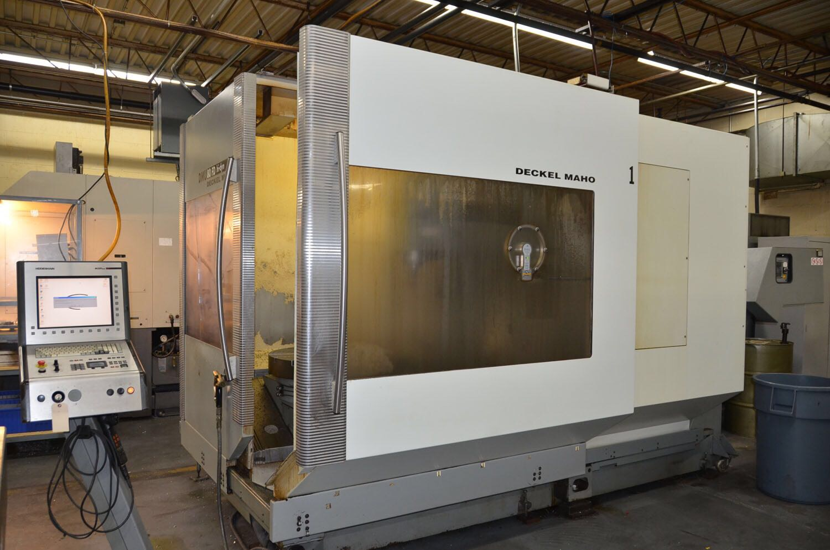
- Make : DECKEL MAHO
- Typ : DMU 80 FD Hi Dyn
- Age : 2003
- No. :

- X Travel : 800
- Y Travel : 700
- Z Travel : 600

- Speed main spindle : 20 – 12.000
- Power main spindle :
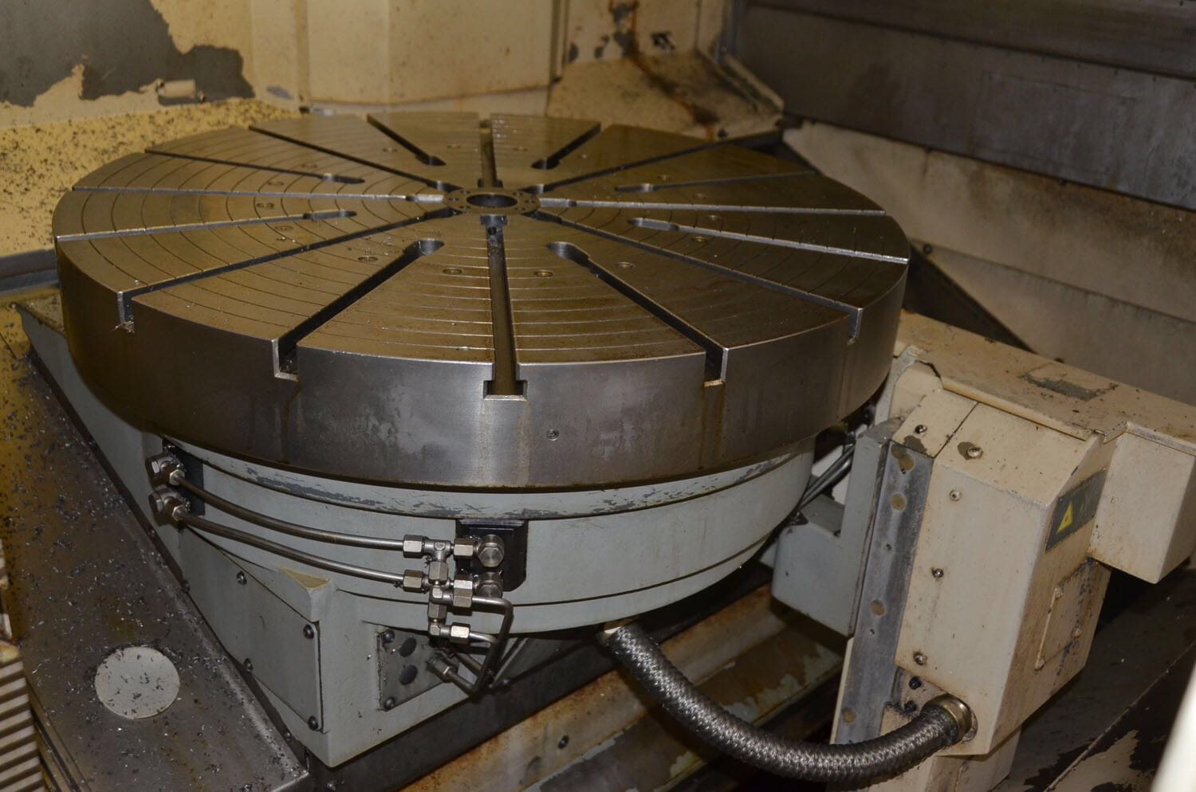
- Max. torq : 130 Nm
- Tool taper : HSK 63

- NC Table pallet changer C Axis
- Table Ø : 800
- Table load : 800
- Table speed : 20 / 500 ( milling / turning)

- NC Automatic head B Axis : 0 – 190 Gr.
- NC Automatic head A Axis: 0 – 130 Gr.
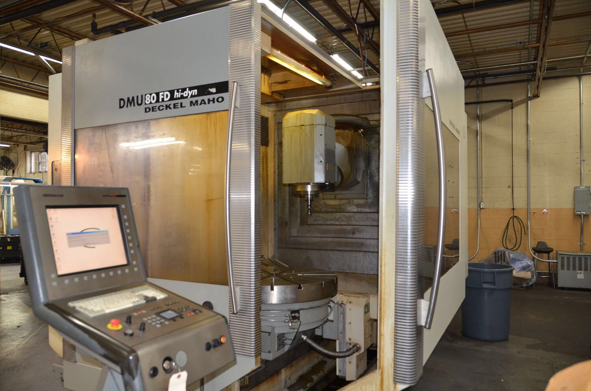

- ATC chain : 30 Positions
- Rapid feed : 60.000 mm/M
- Feed rate : 60.000 mm/M

- Control iTNC 530
- Chip conveyor
- High pressure coolant Knoll
- Blum laser tool length measure & broken tool detection

Please Note: The above information has been obtained to the best of our ability and belief from, and from the manufacturers where possible. It is given in good faith, but its accuracy can not be guaranteed. Accordingly, it will not form a representation or constitute contractual terms. We advise you to check any vital details!
